MITS Advanced Research Techniques

Research Report

Candidate:

Student Name
Higher Education Department
Victorian Institute of Technology

Report Title:
IMPACT OF ARTIFICIAL INTELLIGENCE ON SOCIETY AND FIRM

Abstract
Artificial intelligence (AI) is referred to as the imitation of hominid intellect in mechanisms that are programmed to think like humans. In today’s world, AI is the most increasing and very popular technology in the internet world. Some several companies or organizations are there who use to implement and execute the functionality of AI. The concept of AI based on the process of human intelligence.

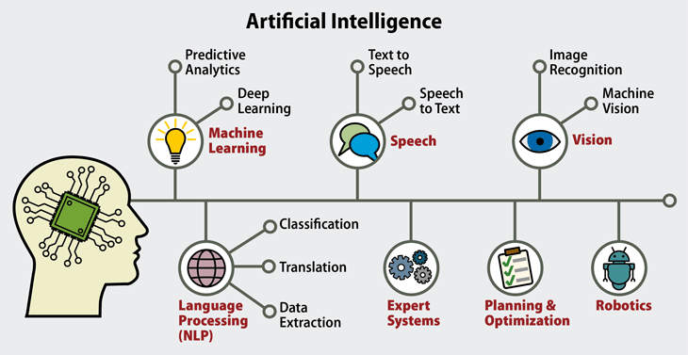
Figure 1: Artificial Intelligence (AI)

The process of human intelligence can be defined in the form of machines and the aspect related to the machines. The process of artificial intelligence (AI) has both a negative and positive impact on society. Nowadays everything is available on the internet and everything is becoming digitized. This functionality increasing the problem-solving compatibilities very effectively. There is some influence of artificial intelligence (AI) on civilization such as:
- Increasingly Capable Systems
- Increasingly Quantified Society
These all are some impact affecting the features of artificial intelligence (AI) in society. In this assignment report, I will identify the influence of AI on humanity so that the thing can be clear that the effect of AI is profitable for the society or not. The presentation of AI is endless because this technology can be implemented in multiple industries. The application of artificial intelligence (AI) can easily the efficiency of the workplace. The risk management process will automatically be very low after using this technology. The work productivity rate will automatically be increased by using this internet technology. By implementing the concept of artificial intelligence (AI) the growth which is measure is very remarkable such as:
- AI helps flag bias and drive diversity
- AI increases efficiency for daily task effort
- AI creates job
At the end of this report, the positive and negative factors and the effect of AI on civilization will be identified.
Introduction
As described in the introduction section it is very clear that this assignment is based on the concept of artificial intelligence (AI) that how this technology is impacting our society. As it is clear that artificial intelligence (AI) is an emerging technology nowadays. Artificial intelligence (AI) is also known as machine intelligence that is a kind of intelligence process or technology that is used to demonstrate by machines. The execution of artificial intelligence (AI) is increasing day by day. In robotics, machine learning and many more platform the use of this technology is becoming very popular. The concept of artificial intelligence (AI) is also known as a computer-controlled robot which gives the accurate result for the proposed solution. Numerous organizations are using this technology that helps in their business growth. A business organization is inventing new things by using or executing this internet technology. As defined in the abstract section artificial intelligence (AI) is continually enhancing the digitalization concept [1].
Artificial intelligence (AI) use to develop or create a non-human system that can do tasks every better than us. There are multiple functionalities or application has been developed by using artificial intelligence (AI) technology such as:
- The human mimic speech application
- Language translate application
- Diagnose cancer medial application system
- Draft legal document and many more
These all are some basic application that has been developed by using the concept of artificial intelligence (AI). In today’s world, people want an easy life and they do not want to do hard work. In many developed countries, they are using the robot for most of the work. Life is becoming very easy by using technology and that is the reason that we and our society are getting attracted to all of this technology which is a positive sign. There is multiple sensor-based applications are also has been developed [2]. This sensor-based application is also the invention of artificial intelligence (AI). Nowadays we can easily differentiate technical and non-technical components or devices. The data collecting capacity and data-generating capacity is also increases because artificial intelligence (AI) gives access to multiple data collecting functionality on a single platform. The machine intelligence is directly connected with the multiple internet servers that use to transfer the data towards this technology.
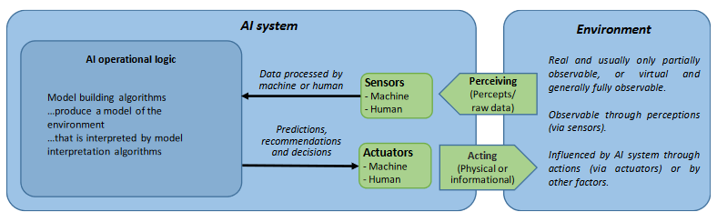
Figure 2: Conceptual view of an AI system
The given diagram is about the conceptual view of an artificial intelligence (AI) system. This diagram mention and define the functionality of artificial intelligence (AI) in the real world [3].
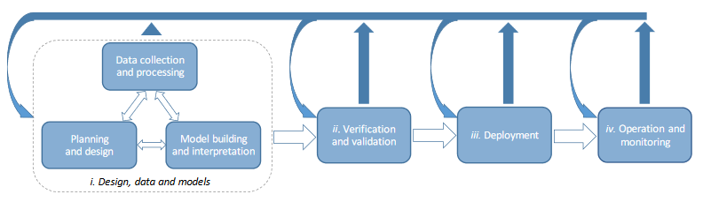
Figure 3: AI System Lifecycle
The given diagram is about the lifecycle of the artificial intelligence (AI) system. The data collection and processing is the most important and very effective factor of this technology and this is used to plan and design the application architecture and create a model-building approach. After doing these steps the data verification has to be done and deployment starts. After deployment of the application the developed application will be monitoring. In real-world there are many applications has been developed by using the concept of artificial intelligence (AI) such as:
- Alexa
- SIRI
- Tesla
- BOXEVER
- Amazon.com
- Netflix
- Pandora, etc. [3]
These application has been developed by using artificial intelligence (AI) technology. This is an impact of this technology on society and business organizations also. There are multiple of voice-based gadgets are available that is an invention of artificial intelligence (AI). The main objective of this assignment is to define and explain every possible aspect of artificial intelligence (AI) in the real world and its impact on society. The business organization is most widely using this technology to make their business more profitable which is an effective approach. The face recognition system is also the invention of artificial intelligence (AI). At the end of this report, I will identify the positive and negative aspects of implementing artificial intelligence (AI). But as I have analyzed there is no negativity of implementing this technology because this technology is making life very easier. The only negative aspect which I can see is security because cybercrime is increasing day by day. So there should be more security patches installed into this system while development and deployment of the system [4].
Literature Review

This Section contains the methodology for the proposed research report… consider any feedback given and the marking guide used for the previous assignment approx. 5 pages

Methodology

This Section contains the methodology for the proposed research report… consider the marking guide used for the previous assignment approx. 3 pages

References

- [1]J. Bryson, "The Past Decade and Future of AI’s Impact on Society | OpenMind", OpenMind, 2020. [Online]. Available: https://www.bbvaopenmind.com/en/articles/the-past-decade-and-future-of-ais-impact-on-society/. [Accessed: 09- Apr- 2020].
- [2]B. Marr, "What Is The Impact Of Artificial Intelligence (AI) On Society?", Bernard Marr, 2020. [Online]. Available: https://bernardmarr.com/default.asp?contentID=1828. [Accessed: 09- Apr- 2020].
- [3]A. Gurría, Ec.europa.eu, 2020. [Online]. Available: https://ec.europa.eu/jrc/communities/sites/jrccties/files/eedfee77-en.pdf. [Accessed: 09- Apr- 2020].
- [4]C. Clifford, "8 ways artificial intelligence is going to change the way you live, work and play in 2018", CNBC, 2020. [Online]. Available: https://www.cnbc.com/2018/01/05/how-artificial-intelligence-will-affect-your-life-and-work-in-2018.html. [Accessed: 09- Apr- 2020].

